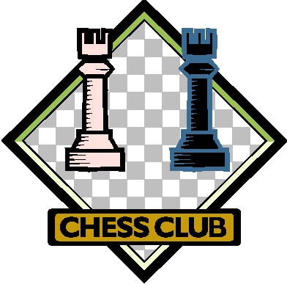

Tournament Results - 2007

Champion - Luke P. - Gr. 7
2nd Place - Pat H. - Grade 7
3rd Place - John Y - Grade 5
4th Place - Joe J. - Grade 8

Girl’s Champion - Maggie M
Grade 8 Champion - Garrett D
Grade 7 Champion - Pat H
Grade 5 Champion - John Y
Grade 4 Champion - Jack C.

