The Wizard of Oz
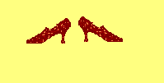
April 11, 2008 at 7:00 PM
April 12, 2008 at 2:00 PM

Presented by St. John Regional School
At the City Auditorium in Concord, NH

Come and see us…
You’ll know you aren’t in Kansas anymore…

