
- Skip to Content
- Skip to Contact

- Business
  - Corporate
  - Small and Medium
  - Pro Video
  - Government
- Education
  - K - 12
  - Higher Education
- Entertainment
  - Home Entertainment
  - Home Theater
  - Gaming
- All Products
  - Business
  - Entertainment
  - Education
  - Accessories
- Store
- Discover
  - Learning Center
  - Presenters University
  - InFocus Presents
- Support
  - Registration
  - Products
  - How-to Guides
  - FAQs
  - Trade-up
  - Repair Status
  - Contact
- Company
  - Contact Us
  - Press Releases
  - Investors
  - Employment
Back | Close

Support

"Good Service" is a synonym for InFocus
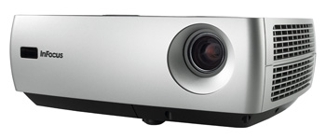

Print this page
You are authorized to purchase a lamp for this product with serial number 7KN22990133. To expedite your lamp order, please print out this confirmation and fax it with your order.
Please contact InFocus directly at 800.660.0024 to order your replacement lamp.
We also recommend that you confirm that your projector is using the latest firmware revision. The latest version extends the lamp life and makes the projector run cooler. Details
SPECIAL NOTE: Installing a 3F or 5F lamp in a projector not approved for an updated lamp will void the lamp warranty.
For your information, our records show that this product is not registered. Please register the product at your

